GAS SENSOR MQ135

The gas sensor module consists of a steel exoskeleton under which a sensing element is housed. This sensing element is subjected to current through connecting leads. This current is known as heating current through it, the gases coming close to the sensing element get ionized and are absorbed by the sensing element. This changes the resistance of the sensing element which alters the value of the current going out of it.

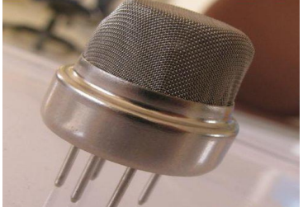

The gas sensing material used in the MQ135 gas sensor is tin dioxide (SnO2), which has low conductivity in clean air. When there is polluted gas in the environment where the sensor is located, the conductivity of the sensor increases with the increase of the concentration of polluted gas in the air. The MQ135 gas sensor has a high sensitivity to ammonia, sulphide, and benzene-based vapours, and is ideal for monitoring smoke and other harmful gases. This sensor can detect a variety of harmful gases and is a low-cost sensor suitable for a variety of applications.

Pin Configuration MQ-135 gas sensor:

From left to right first pins are as follows:

* A0 Analog output
* D0 Digital output
* GND Ground Vcc
* Supply (5V)



Specifications of MQ-135 gas sensor:

• Wide detecting scope

• Fast response and High sensitivity

• Stable and long-life Simple drive circuit

• Used in air quality control equipment for buildings/offices, is suitable for detecting of NH3, NOx, alcohol, Benzene, smoke, CO2, etc.

• Size: 35mm x 22mm x 23mm (length x width x height)

• Working voltage: DC 5 V

• Signal output instruction.

• Dual signal output (analog output, and high/low digital output)

• 0 ~ 4.2V analog output voltage, the higher the concentration the higher the voltage.

The MQ-135 gas sensor has an inbuilt variable resistor (sense resistor) that changes its [resistance](https://www.codrey.com/resistor/electrical-resistance/) value according to the concentration of gas. If the gas concentration is high, the resistance decreases, and if the gas concentration is low, the [resistance](https://www.codrey.com/resistor/electrical-resistance/) increases. The MQ-135 gas sensor basically needs only one key component as the external component – just a load resistor. The load resistor serves to adjust the sensor’s sensitivity and accuracy. The value can range anywhere from 10KΩ to 47KΩ (the higher the resistance, the more sensitive the sensor becomes). Since sense resistance (Rs) value of MQ-135 gas sensor is different for various kinds and various concentration of gases, sensitivity adjustment becomes very necessary.

The datasheet recommends to calibrate the MQ-135 sensor for 100ppm NH3 or 50ppm Alcohol concentration in air and use value of the load [resistor](https://www.codrey.com/resistor/resistor-basics/) (RL) about 20KΩ (10KΩ to 47KΩ). But in the MQ-135 Chinese module introduced here, we can see a 1KΩ (102) load [resistor](https://www.codrey.com/resistor/resistor-basics/). Not a good practice of course!

[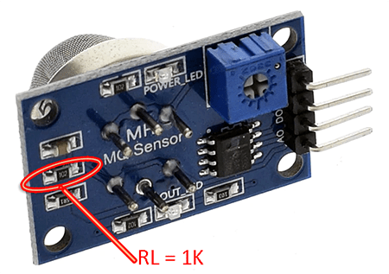](https://www.codrey.com/wp-content/uploads/2020/01/MQ135-Load-Resistor-Location.png)

So if you want to build a microcontroller-based trusty air quality monitor yourself with MQ-135, you should replace the 1KΩ load resistor with one 10-22KΩ load resistor to get appropriate readings. By the way, it’s worthy to note down the acceptable CO2 ppm values:

* 400ppm – 750ppm: Good for health
* 750 ppm – 1200 ppm: Take care
* 1200 ppm (and above): Harmful to health

Next figure depicts the typical sensitivity characteristics of MQ135 gas sensor for several gases. That means the given plot tells us the concentration of a gas in part per million (ppm) according to the [resistance](https://www.codrey.com/resistor/electrical-resistance/) ratio of the sensor (Rs/Ro). Here, Rs is the resistance of the sensor that changes depending on the concentration of gas, whereas Ro is the resistance of the sensor at a known concentration without the presence of other gases, or in the fresh air.

[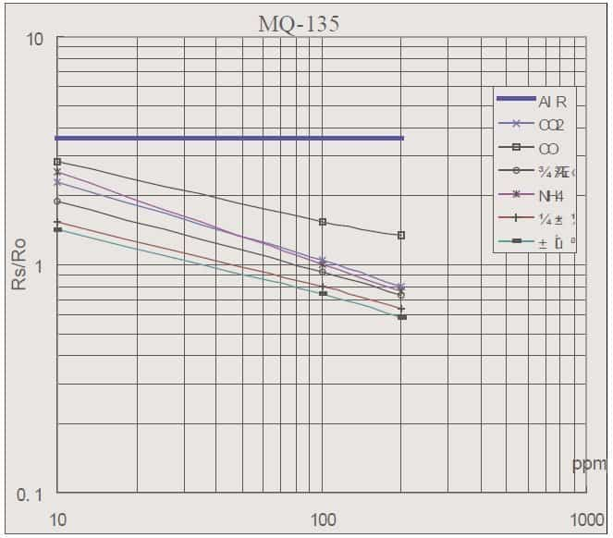](https://www.codrey.com/wp-content/uploads/2020/01/Air-Quality-Sensor-MQ135-Rs-Ro-Graph.jpg)

In this sensitivity characteristic curve (borrowed from the datasheet), Ro is the sensor resistance at 100ppm of NH3 in clean air, and Rs is the sensor resistance at various concentrations of gases.

If you want to do anything serious with MQ-135 gas sensor, then you should learn to analyse this plot pretty well. However that needs some skill and patience as the scale is log-log i.e. in a linear scale, the behaviour of the gas concentration with respect to the resistance ratio is exponential (not linear). For determining Rs/Ro, you can use the fact that the Rs/Ro ratio is a constant in clean air. Also, by definition, only the Rs changes when a gas is present while Ro remains constant. Therefore, if you can determine the value of Rs in clean air, you can also determine Ro and ultimately Rs/Ro. A bit indigestible for a novice, but I’ll try to shed some light on it later. Meanwhile simply note that in science and engineering, a log–log plot is a two-dimensional graph/plot of numerical data that uses logarithmic scales on both the horizontal and vertical axes.

[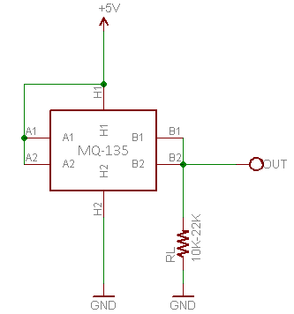](https://www.codrey.com/wp-content/uploads/2020/01/Air-Quality-Sensor-MQ135-Basic-Setup.png)

In principle, MQ-135’s internal sensor resistor RS and external load resistor RL forms a voltage divider. In the datasheet we can see that the sensor resistor has a value of 30KΩ-200KΩ (100ppm NH3). And, as pointed on the log–log plot, RS in fresh air (under certain temperature and humidity) will be a constant value. The main part of the calibration is to calculate the RO by sampling and averaging the readings when the gas sensor is placed in fresh air. Once the RO is derived, Rs value can be calculated.

**Challenges and Considerations:**

While the**MQ-135 sensor** is a valuable tool for gas detection, there are certain challenges and considerations that users should be aware of:

**Cross-Sensitivity:**

The **MQ-135 sensor** exhibits cross-sensitivity, meaning it may respond to multiple gases, not just the target gas. This cross-sensitivity can affect the accuracy of the sensor, especially in environments where multiple gases are present.

**Temperature and Humidity Dependency:**

The sensor’s performance is influenced by temperature and humidity levels. Users must take these factors into account and, if necessary, implement temperature and humidity compensation techniques to ensure accurate readings.

**Limited Gas Specificity:**

While the **MQ-135 sensor** can detect a variety of gases, it lacks specificity for certain gases. Users should be cautious when interpreting readings and consider potential interference from other gases in the environment.

**DIY Projects and Education:**

The accessibility and affordability of the **MQ-135 sensor** make it an ideal component for do-it-yourself (DIY) projects and educational purposes. Students, hobbyists, and electronics enthusiasts often incorporate the MQ-135 into their projects to learn about gas sensing principles, microcontroller interfacing, and data interpretation. This hands-on experience helps individuals develop practical skills in electronics and sensor technology.

**Health Monitoring Devices:**

The **MQ-135 sensor** can be utilized in wearable devices designed for health monitoring. By integrating this sensor into devices such as smartwatches or portable air quality monitors, individuals can track their exposure to certain gases and pollutants. This application becomes particularly relevant in urban environments where air quality can vary significantly.

**Automotive Air Quality Systems:**

With a growing emphasis on environmental concerns and the impact of vehicular emissions, the **MQ-135 sensor** can be employed in automotive air quality systems. These systems can monitor the air inside a vehicle’s cabin and activate ventilation or air purification systems when pollutant levels exceed predefined thresholds, contributing to a healthier driving experience.

**Agricultural Applications:**

The **MQ-135 sensor** finds applications in agriculture for monitoring the air quality in greenhouses. It can detect gases emitted by plants or pesticides, helping farmers optimize environmental conditions for crop growth. Additionally, the sensor can be part of automated systems that control ventilation and gas levels to enhance crop productivity.

**Conclusion**

The **MQ-135 gas sensor** stands as a reliable and cost-effective solution for gas detection and air quality monitoring applications. Its versatility and ease of integration make it a popular choice among hobbyists, researchers, and industry professionals alike. As technology continues to advance, the **MQ-135 sensor**and its counterparts will likely play an increasingly important role in creating safer and healthier living environments.

## Freundlich Adsorption Isotherms

Freundlich Adsorption isotherms depict curves showing the variations in gas adsorbed by the solid at a constant temperature and pressure. It is expressed as x/m = Kp1/n where x is the adsorbate mass, m is the adsorbent mass, n and K are constants for an adsorbent and adsorbate at a temperature.

The Freundlich isotherms are represented in graphical formations. In this graphical representation, the amount (mass) of the gas being adsorbed is plotted against the pressure and is represented as curves on the graphs. When the pressure is fixed, there is a decrease in physisorption with a relative increase in temperature. The saturation point is depicted when the curve reaches a high point. This equation is also depicted through the log as log x/m = log k + 1/n log P. log x/m is plotted on to the y axis and log P is plotted on the x-axis. When there are solutions then the equation becomes x/m = k (C) 1/n or log x/m = log k + 1/n log C. Here, C is the concentration of adsorbate.

## Freundlich Adsorption Isotherm Equation:

The adsorption equation of the isotherm is represented as:

* x/m = Kp1/nwhere x is the adsorbate mass, m is the adsorbent mass, n and K are constants for an adsorbent and adsorbate at a temperature and 1/n is essentially the value at high pressure which is 0 with p being pressure.
* log x/m = log k + 1/n log P. log x/m is plotted on the y axis and log P is plotted on the x-axis.
* x/m = Kc1/n or or log x/m = log k + 1/n log C. Here, C is the concentration of adsorbate.

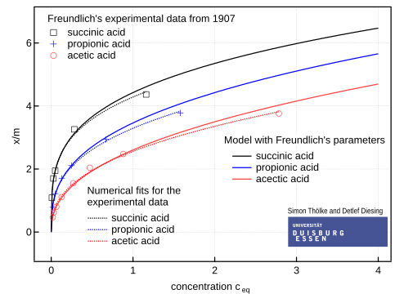

### **Conclusion:**

The various graphical models of adsorptions help in understanding the characteristics and functions of adsorption clearly. Adsorption is applied to produce a vacuum, removing colouring materials from solutions, it is used to remove and filter impurities in gas masks and used in heterogeneous catalysts.